Jenis_Kelamin

Statistics
Jenis_Kelamin
N | Valid | 361
 | Missing | 0

Jenis_Kelamin
 |  | Frequency | Percent | Valid Percent | Cumulative Percent
Valid | Laki-laki | 106 | 29.4 | 29.4 | 29.4
 | Perempuan | 255 | 70.6 | 70.6 | 100.0
 | Total | 361 | 100.0 | 100.0

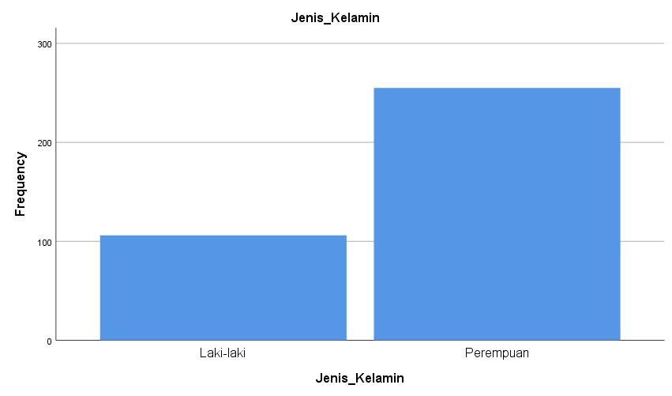

Usia
Statistics
Usia
N | Valid | 361
 | Missing | 0

Usia
 |  | Frequency | Percent | Valid Percent | Cumulative Percent
Valid | 17 - 25 tahun | 151 | 41.8 | 41.8 | 41.8
 | 26 - 35 tahun | 174 | 48.2 | 48.2 | 90.0
 | 36 - 45 tahun | 36 | 10.0 | 10.0 | 100.0
 | Total | 361 | 100.0 | 100.0

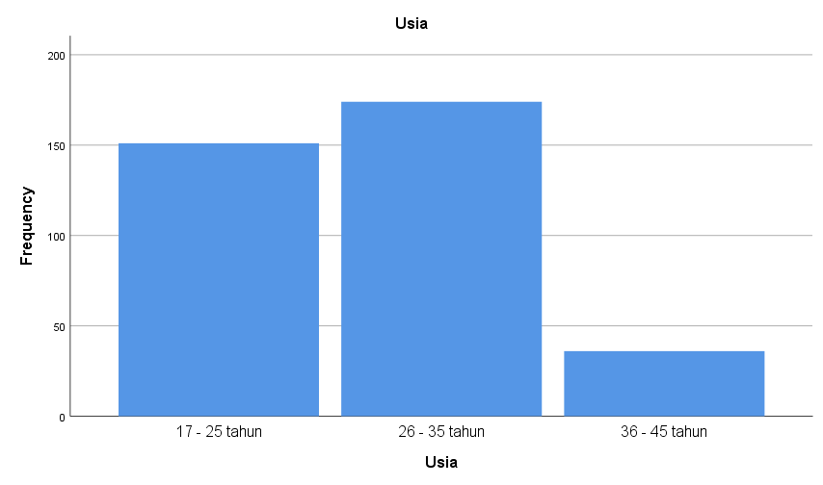

Tingkat Penggunaan Instagram

Statistics
Tingkat_penggunaan_Instagram
N | Valid | 361
 | Missing | 0

Tingkat_penggunaan_Instagram
 |  | Frequency | Percent | Valid Percent | Cumulative Percent
Valid | Cukup Sering | 71 | 19.7 | 19.7 | 19.7
 | Jarang | 14 | 3.9 | 3.9 | 23.5
 | Sangat Jarang | 4 | 1.1 | 1.1 | 24.7
 | Sangat sering | 140 | 38.8 | 38.8 | 63.4
 | Sering | 132 | 36.6 | 36.6 | 100.0
 | Total | 361 | 100.0 | 100.0

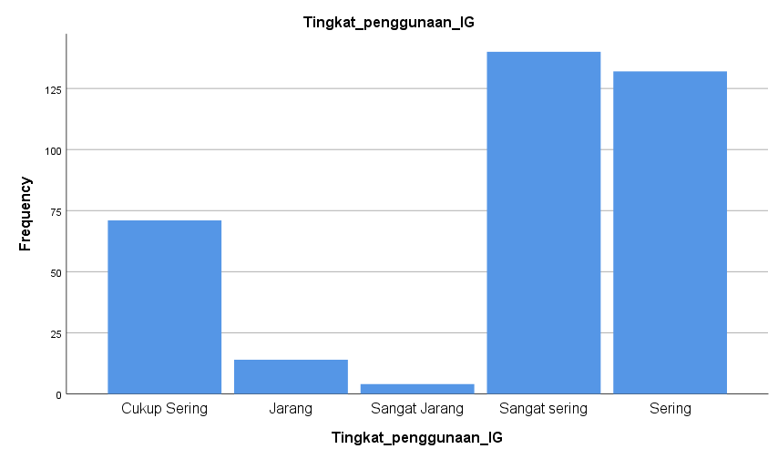

Waktu Mengakses Instagram

Statistics
Waktu_akses_IG
N | Valid | 361
 | Missing | 0

Waktu_akses_IG
 |  | Frequency | Percent | Valid Percent | Cumulative Percent
Valid | > 4 jam | 69 | 19.1 | 19.1 | 19.1
 | 0 - 1 jam | 40 | 11.1 | 11.1 | 30.2
 | 1 - 2 jam | 109 | 30.2 | 30.2 | 60.4
 | 2 - 3 jam | 91 | 25.2 | 25.2 | 85.6
 | 3 - 4 jam | 52 | 14.4 | 14.4 | 100.0
 | Total | 361 | 100.0 | 100.0

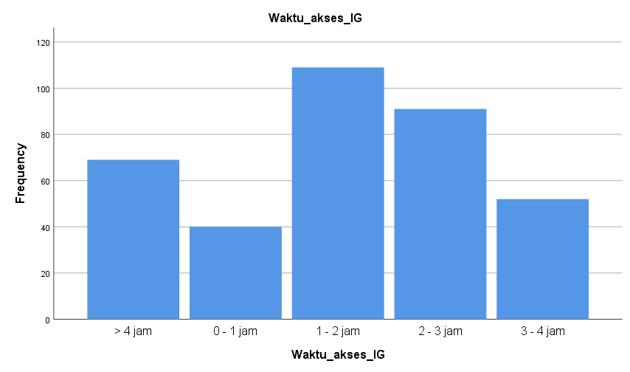
Jumlah Akses Instagram @darihalte_kehalte per Hari

Statistics
Jumlah_akses_darihaltekehalte
N | Valid | 361
 | Missing | 0

Jumlah_akses_darihaltekehalte
 |  | Frequency | Percent | Valid Percent | Cumulative Percent
Valid | > 5 kali | 31 | 8.6 | 8.6 | 8.6
 | 1 kali | 133 | 36.8 | 36.8 | 45.4
 | 2 - 3 kali | 132 | 36.6 | 36.6 | 82.0
 | 3 - 4 kali | 48 | 13.3 | 13.3 | 95.3
 | 4 - 5 kali | 17 | 4.7 | 4.7 | 100.0
 | Total | 361 | 100.0 | 100.0

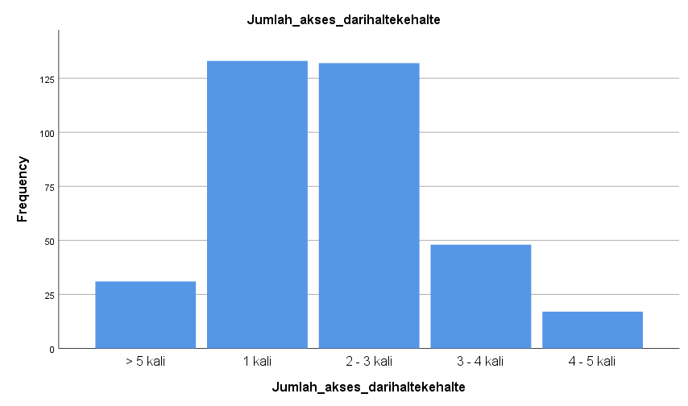

Reliability Scale: Kebutuhan Informasi Pengguna

Case Processing Summary
 |  | N | %
Cases | Valid | 361 | 100.0
 | Excludedª | 0 | .0
 | Total | 361 | 100.0
a. Listwise deletion based on all variables in the procedure.

Reliability Statistics
Cronbach's Alpha | N of Items
.841 | 10

Reliability Scale: Penggunaan Akun Instagram @darihalte_kehalte

Case Processing Summary
 |  | N | %
Cases | Valid | 361 | 100.0
 | Excludedª | 0 | .0
 | Total | 361 | 100.0
a. Listwise deletion based on all variables in the procedure.

Reliability Statistics
Cronbach's Alpha | N of Items
.904 | 15

Reliability Scale: Pemenuhan Kebutuhan Informasi melalui akun Instagram @darihalte_kehalte

Case Processing Summary
 |  | N | %
Cases | Valid | 361 | 100.0
 | Excludedª | 0 | .0
 | Total | 361 | 100.0
a. Listwise deletion based on all variables in the procedure.

Reliability Statistics
Cronbach's Alpha | N of Items
.899 | 10

Reliability Scale: Hambatan Pemenuhan Kebutuhan Informasi

Case Processing Summary
 |  | N | %
Cases | Valid | 361 | 100.0
 | Excludedª | 0 | .0
 | Total | 361 | 100.0
a. Listwise deletion based on all variables in the procedure.

Reliability Statistics
Cronbach's Alpha | N of Items
.916 | 10

Reliability Scale: All Variable
Case Processing Summary
 |  | N | %
Cases | Valid | 361 | 100.0
 | Excludedª | 0 | .0
 | Total | 361 | 100.0
a. Listwise deletion based on all variables in the procedure.

Reliability Statistics
Cronbach's Alpha | Cronbach's Alpha Based on Standardized Items | N of Items
.894 | .911 | 45

Item Statistics
 | Mean | Std. Deviation | N
Kebutuhan Informasi Pengguna | 4.28 | .635 | 361
KIP2 | 4.42 | .583 | 361
KIP3 | 4.01 | .965 | 361
KIP4 | 4.18 | .818 | 361
KIP5 | 4.08 | .824 | 361
KIP6 | 4.16 | .819 | 361
KIP7 | 4.39 | .661 | 361
KIP8 | 4.46 | .699 | 361
KIP9 | 4.32 | .715 | 361
KIP10 | 4.45 | .586 | 361
Penggunaan Akun Instagram @darihalte_kehalte | 3.92 | .730 | 361
PAI2 | 3.79 | .706 | 361
PAI3 | 3.79 | .756 | 361
PAI4 | 4.37 | .583 | 361
PAI5 | 4.25 | .633 | 361
PAI6 | 4.37 | .586 | 361
PAI7 | 3.99 | .713 | 361
PAI8 | 4.36 | .705 | 361
PAI9 | 4.12 | .852 | 361
PAI10 | 4.13 | .724 | 361
PAI11 | 4.25 | .659 | 361
PAI12 | 4.33 | .657 | 361
PAI13 | 4.29 | .756 | 361
PAI14 | 4.63 | .501 | 361
PAI15 | 4.35 | .653 | 361
Pemenuhan Kebutuhan Informasi melalui akun Instagram @darihalte_kehalte | 4.27 | .669 | 361
PK2 | 4.31 | .614 | 361
PK3 | 4.32 | .608 | 361
PK4 | 4.09 | .798 | 361
PK5 | 4.14 | .731 | 361
PK6 | 4.13 | .717 | 361
PK7 | 4.16 | .698 | 361
PK8 | 4.32 | .592 | 361
PK9 | 4.15 | .717 | 361
PK10 | 4.27 | .637 | 361
Hambatan Pemenuhan Kebutuhan Informasi | 2.23 | .876 | 361
HPKI2 | 2.24 | .903 | 361
HPKI3 | 2.10 | .884 | 361
HPKI4 | 2.70 | .935 | 361
HPKI5 | 2.48 | .955 | 361
HPKI6 | 2.56 | 1.021 | 361
HPKI7 | 2.07 | .878 | 361
HPKI8 | 1.80 | .819 | 361
HPKI9 | 1.99 | .856 | 361
HPKI10 | 1.92 | .816 | 361

Summary Item Statistics
 | Mean | Minimum | Maximum | Range | Maximum / Minimum | Variance | N of Items
Item Means | 3.777 | 1.801 | 4.626 | 2.825 | 2.569 | .761 | 45

Item-Total Statistics
 | Scale Mean if Item Deleted | Scale Variance if Item Deleted | Corrected Item-Total Correlation | Squared Multiple Correlation | Cronbach's Alpha if Item Deleted
Kebutuhan Informasi Pengguna | 165.68 | 190.186 | .564 | . | .890
KIP2 | 165.53 | 190.705 | .585 | . | .890
KIP3 | 165.94 | 188.264 | .426 | . | .891
KIP4 | 165.78 | 188.871 | .486 | . | .890
KIP5 | 165.88 | 188.568 | .495 | . | .890
KIP6 | 165.80 | 188.675 | .494 | . | .890
KIP7 | 165.57 | 190.556 | .519 | . | .890
KIP8 | 165.50 | 193.378 | .339 | . | .893
KIP9 | 165.64 | 190.330 | .488 | . | .891
KIP10 | 165.50 | 190.206 | .614 | . | .890
Penggunaan Akun Instagram @darihalte_kehalte | 166.04 | 192.113 | .386 | . | .892
PAI2 | 166.17 | 191.011 | .459 | . | .891
PAI3 | 166.17 | 191.535 | .399 | . | .892
PAI4 | 165.59 | 192.226 | .489 | . | .891
PAI5 | 165.71 | 191.736 | .475 | . | .891
PAI6 | 165.59 | 191.592 | .525 | . | .891
PAI7 | 165.97 | 190.166 | .498 | . | .890
PAI8 | 165.60 | 191.268 | .446 | . | .891
PAI9 | 165.83 | 188.283 | .490 | . | .890
PAI10 | 165.83 | 190.959 | .448 | . | .891
PAI11 | 165.70 | 192.337 | .420 | . | .892
PAI12 | 165.63 | 190.939 | .501 | . | .891
PAI13 | 165.67 | 190.326 | .459 | . | .891
PAI14 | 165.33 | 193.656 | .470 | . | .891
PAI15 | 165.61 | 191.483 | .473 | . | .891
Pemenuhan Kebutuhan Informasi melalui akun Instagram @darihalte_kehalte | 165.69 | 189.765 | .556 | . | .890
PKI2 | 165.65 | 190.374 | .573 | . | .890
PKI3 | 165.63 | 190.660 | .562 | . | .890
PKI4 | 165.87 | 188.975 | .495 | . | .890
PKI5 | 165.81 | 188.307 | .579 | . | .889
PKI6 | 165.83 | 189.498 | .530 | . | .890
PKI7 | 165.80 | 189.525 | .544 | . | .890
PKI8 | 165.64 | 189.826 | .630 | . | .889
PKI9 | 165.81 | 188.381 | .587 | . | .889
PKI10 | 165.68 | 189.550 | .599 | . | .889
Hambatan Pemenuhan Kebutuhan Informasi | 167.73 | 197.527 | .088 | . | .897
HPKI2 | 167.72 | 197.908 | .068 | . | .897
HPKI3 | 167.86 | 198.385 | .052 | . | .897
HPKI4 | 167.26 | 197.067 | .096 | . | .897
HPKI5 | 167.48 | 197.911 | .061 | . | .898
HPKI6 | 167.40 | 197.574 | .064 | . | .898
HPKI7 | 167.89 | 198.143 | .063 | . | .897
HPKI8 | 168.16 | 198.350 | .062 | . | .897
HPKI9 | 167.96 | 199.279 | .019 | . | .898
HPKI10 | 168.04 | 198.696 | .048 | . | .897

Scale Statistics
Mean | Variance | Std. Deviation | N of Items
169.96 | 200.462 | 14.158 | 45

Frequencies Kebutuhan Informasi Pengguna
Statistics
 |  | Kebutuhan Informasi Pengguna | KIP2 | KIP3 | KIP4 | KIP5 | KIP6 | KIP7 | KIP8 | KIP9 | KIP10
N | Valid | 361 | 361 | 361 | 361 | 361 | 361 | 361 | 361 | 361 | 361
 | Missing | 0 | 0 | 0 | 0 | 0 | 0 | 0 | 0 | 0 | 0
Mean |  | 4.28 | 4.42 | 4.01 | 4.18 | 4.08 | 4.16 | 4.39 | 4.46 | 4.32 | 4.45

Frequency Table
KIP1
 |  | Frequency | Percent | Valid Percent | Cumulative Percent
Valid | Tidak Setuju | 3 | .8 | .8 | .8
 | Netral | 27 | 7.5 | 7.5 | 8.3
 | Setuju | 196 | 54.3 | 54.3 | 62.6
 | Sangat Setuju | 135 | 37.4 | 37.4 | 100.0
 | Total | 361 | 100.0 | 100.0

KIP2
 |  | Frequency | Percent | Valid Percent | Cumulative Percent
Valid | Tidak Setuju | 1 | .3 | .3 | .3
 | Netral | 14 | 3.9 | 3.9 | 4.2
 | Setuju | 177 | 49.0 | 49.0 | 53.2
 | Sangat Setuju | 169 | 46.8 | 46.8 | 100.0
 | Total | 361 | 100.0 | 100.0

KIP3
 |  | Frequency | Percent | Valid Percent | Cumulative Percent
Valid | Sangat Tidak Setuju | 3 | .8 | .8 | .8
 | Tidak Setuju | 26 | 7.2 | 7.2 | 8.0
 | Netral | 69 | 19.1 | 19.1 | 27.1
 | Setuju | 128 | 35.5 | 35.5 | 62.6
 | Sangat Setuju | 135 | 37.4 | 37.4 | 100.0
 | Total | 361 | 100.0 | 100.0

KIP4
 |  | Frequency | Percent | Valid Percent | Cumulative Percent
Valid | Sangat Tidak Setuju | 1 | .3 | .3 | .3
 | Tidak Setuju | 15 | 4.2 | 4.2 | 4.4
 | Netral | 43 | 11.9 | 11.9 | 16.3
 | Setuju | 162 | 44.9 | 44.9 | 61.2
 | Sangat Setuju | 140 | 38.8 | 38.8 | 100.0
 | Total | 361 | 100.0 | 100.0

KIP5
 |  | Frequency | Percent | Valid Percent | Cumulative Percent
Valid | Tidak Setuju | 19 | 5.3 | 5.3 | 5.3
 | Netral | 52 | 14.4 | 14.4 | 19.7
 | Setuju | 171 | 47.4 | 47.4 | 67.0
 | Sangat Setuju | 119 | 33.0 | 33.0 | 100.0
 | Total | 361 | 100.0 | 100.0

KIP6
 |  | Frequency | Percent | Valid Percent | Cumulative Percent
Valid | Sangat Tidak Setuju | 1 | .3 | .3 | .3
 | Tidak Setuju | 16 | 4.4 | 4.4 | 4.7
 | Netral | 42 | 11.6 | 11.6 | 16.3
 | Setuju | 166 | 46.0 | 46.0 | 62.3
 | Sangat Setuju | 136 | 37.7 | 37.7 | 100.0
 | Total | 361 | 100.0 | 100.0

KIP7
 |  | Frequency | Percent | Valid Percent | Cumulative Percent
Valid | Tidak Setuju | 4 | 1.1 | 1.1 | 1.1
 | Netral | 24 | 6.6 | 6.6 | 7.8
 | Setuju | 162 | 44.9 | 44.9 | 52.6
 | Sangat Setuju | 171 | 47.4 | 47.4 | 100.0
 | Total | 361 | 100.0 | 100.0

KIP8
 |  | Frequency | Percent | Valid Percent | Cumulative Percent
Valid | Sangat Tidak Setuju | 1 | .3 | .3 | .3
 | Tidak Setuju | 2 | .6 | .6 | .8
 | Netral | 31 | 8.6 | 8.6 | 9.4
 | Setuju | 123 | 34.1 | 34.1 | 43.5
 | Sangat Setuju | 204 | 56.5 | 56.5 | 100.0
 | Total | 361 | 100.0 | 100.0

KIP9
 |  | Frequency | Percent | Valid Percent | Cumulative Percent
Valid | Sangat Tidak Setuju | 2 | .6 | .6 | .6
 | Tidak Setuju | 3 | .8 | .8 | 1.4
 | Netral | 32 | 8.9 | 8.9 | 10.2
 | Setuju | 166 | 46.0 | 46.0 | 56.2
 | Sangat Setuju | 158 | 43.8 | 43.8 | 100.0
 | Total | 361 | 100.0 | 100.0

KIP10
 |  | Frequency | Percent | Valid Percent | Cumulative Percent
Valid | Tidak Setuju | 1 | .3 | .3 | .3
 | Netral | 14 | 3.9 | 3.9 | 4.2
 | Setuju | 166 | 46.0 | 46.0 | 50.1
 | Sangat Setuju | 180 | 49.9 | 49.9 | 100.0
 | Total | 361 | 100.0 | 100.0

Reliability Scale: Pertanyaan fungsi informasi

Case Processing Summary
 |  | N | %
Cases | Valid | 361 | 100.0
 | Excludedª | 0 | .0
 | Total | 361 | 100.0
a. Listwise deletion based on all variables in the procedure.

Reliability Statistics
Cronbach's Alpha | N of Items
.819 | 2

Reliability Scale: Pertanyaan subjek informasi

Case Processing Summary
 |  | N | %
Cases | Valid | 361 | 100.0
 | Excludedª | 0 | .0
 | Total | 361 | 100.0
a. Listwise deletion based on all variables in the procedure.

Reliability Statistics
Cronbach's Alpha | N of Items
.766 | 5

Statistics
 |  | Penggunaan Akun Instagram @darihalte_kehalte | PAI2 | PAI3 | PAI4 | PAI5 | PAI6 | PAI7 | PAI8 | PAI9 | PAI10 | PAI11 | PAI12 | PAI13 | PAI14 | PAI15
N | Valid | 361 | 361 | 361 | 361 | 361 | 361 | 361 | 361 | 361 | 361 | 361 | 361 | 361 | 361 | 361
 | Missing | 0 | 0 | 0 | 0 | 0 | 0 | 0 | 0 | 0 | 0 | 0 | 0 | 0 | 0 | 0
Mean |  | 3.92 | 3.79 | 3.79 | 4.37 | 4.25 | 4.37 | 3.99 | 4.36 | 4.12 | 4.13 | 4.25 | 4.33 | 4.29 | 4.63 | 4.35

Frequency Table

Penggunaan Akun Instagram @darihalte_kehalte
 |  | Frequency | Percent | Valid Percent | Cumulative Percent
Valid | Sangat Tidak Setuju | 2 | .6 | .6 | .6
 | Tidak Setuju | 6 | 1.7 | 1.7 | 2.2
 | Netral | 81 | 22.4 | 22.4 | 24.7
 | Setuju | 201 | 55.7 | 55.7 | 80.3
 | Sangat Setuju | 71 | 19.7 | 19.7 | 100.0
 | Total | 361 | 100.0 | 100.0

PAI2
 |  | Frequency | Percent | Valid Percent | Cumulative Percent
Valid | Tidak Setuju | 6 | 1.7 | 1.7 | 1.7
 | Netral | 117 | 32.4 | 32.4 | 34.1
 | Setuju | 184 | 51.0 | 51.0 | 85.0
 | Sangat Setuju | 54 | 15.0 | 15.0 | 100.0
 | Total | 361 | 100.0 | 100.0

PAI3
 |  | Frequency | Percent | Valid Percent | Cumulative Percent
Valid | Sangat Tidak Setuju | 1 | .3 | .3 | .3
 | Tidak Setuju | 10 | 2.8 | 2.8 | 3.0
 | Netral | 113 | 31.3 | 31.3 | 34.3
 | Setuju | 177 | 49.0 | 49.0 | 83.4
 | Sangat Setuju | 60 | 16.6 | 16.6 | 100.0
 | Total | 361 | 100.0 | 100.0

PAI4
 |  | Frequency | Percent | Valid Percent | Cumulative Percent
Valid | Tidak Setuju | 1 | .3 | .3 | .3
 | Netral | 16 | 4.4 | 4.4 | 4.7
 | Setuju | 192 | 53.2 | 53.2 | 57.9
 | Sangat Setuju | 152 | 42.1 | 42.1 | 100.0
 | Total | 361 | 100.0 | 100.0

PAI5
 |  | Frequency | Percent | Valid Percent | Cumulative Percent
Valid | Tidak Setuju | 3 | .8 | .8 | .8
 | Netral | 29 | 8.0 | 8.0 | 8.9
 | Setuju | 203 | 56.2 | 56.2 | 65.1
 | Sangat Setuju | 126 | 34.9 | 34.9 | 100.0
 | Total | 361 | 100.0 | 100.0

PAI6
 |  | Frequency | Percent | Valid Percent | Cumulative Percent
Valid | Sangat Tidak Setuju | 1 | .3 | .3 | .3
 | Tidak Setuju | 1 | .3 | .3 | .6
 | Netral | 11 | 3.0 | 3.0 | 3.6
 | Setuju | 200 | 55.4 | 55.4 | 59.0
 | Sangat Setuju | 148 | 41.0 | 41.0 | 100.0
 | Total | 361 | 100.0 | 100.0

PAI7
 |  | Frequency | Percent | Valid Percent | Cumulative Percent
Valid | Sangat Tidak Setuju | 2 | .6 | .6 | .6
 | Tidak Setuju | 1 | .3 | .3 | .8
 | Netral | 78 | 21.6 | 21.6 | 22.4
 | Setuju | 197 | 54.6 | 54.6 | 77.0
 | Sangat Setuju | 83 | 23.0 | 23.0 | 100.0
 | Total | 361 | 100.0 | 100.0

PAI8
 |  | Frequency | Percent | Valid Percent | Cumulative Percent
Valid | Tidak Setuju | 5 | 1.4 | 1.4 | 1.4
 | Netral | 33 | 9.1 | 9.1 | 10.5
 | Setuju | 151 | 41.8 | 41.8 | 52.4
 | Sangat Setuju | 172 | 47.6 | 47.6 | 100.0
 | Total | 361 | 100.0 | 100.0

PAI9
 |  | Frequency | Percent | Valid Percent | Cumulative Percent
Valid | Sangat Tidak Setuju | 1 | .3 | .3 | .3
 | Tidak Setuju | 16 | 4.4 | 4.4 | 4.7
 | Netral | 57 | 15.8 | 15.8 | 20.5
 | Setuju | 150 | 41.6 | 41.6 | 62.0
 | Sangat Setuju | 137 | 38.0 | 38.0 | 100.0
 | Total | 361 | 100.0 | 100.0

PAI10
 |  | Frequency | Percent | Valid Percent | Cumulative Percent
Valid | Sangat Tidak Setuju | 1 | .3 | .3 | .3
 | Tidak Setuju | 2 | .6 | .6 | .8
 | Netral | 62 | 17.2 | 17.2 | 18.0
 | Setuju | 180 | 49.9 | 49.9 | 67.9
 | Sangat Setuju | 116 | 32.1 | 32.1 | 100.0
 | Total | 361 | 100.0 | 100.0

PAI11
 |  | Frequency | Percent | Valid Percent | Cumulative Percent
Valid | Sangat Tidak Setuju | 1 | .3 | .3 | .3
 | Tidak Setuju | 2 | .6 | .6 | .8
 | Netral | 32 | 8.9 | 8.9 | 9.7
 | Setuju | 195 | 54.0 | 54.0 | 63.7
 | Sangat Setuju | 131 | 36.3 | 36.3 | 100.0
 | Total | 361 | 100.0 | 100.0

PAI12
 |  | Frequency | Percent | Valid Percent | Cumulative Percent
Valid | Tidak Setuju | 3 | .8 | .8 | .8
 | Netral | 29 | 8.0 | 8.0 | 8.9
 | Setuju | 176 | 48.8 | 48.8 | 57.6
 | Sangat Setuju | 153 | 42.4 | 42.4 | 100.0
 | Total | 361 | 100.0 | 100.0

PAI13
 |  | Frequency | Percent | Valid Percent | Cumulative Percent
Valid | Sangat Tidak Setuju | 2 | .6 | .6 | .6
 | Tidak Setuju | 5 | 1.4 | 1.4 | 1.9
 | Netral | 39 | 10.8 | 10.8 | 12.7
 | Setuju | 157 | 43.5 | 43.5 | 56.2
 | Sangat Setuju | 158 | 43.8 | 43.8 | 100.0
 | Total | 361 | 100.0 | 100.0

PAI14
 |  | Frequency | Percent | Valid Percent | Cumulative Percent
Valid | Netral | 3 | .8 | .8 | .8
 | Setuju | 129 | 35.7 | 35.7 | 36.6
 | Sangat Setuju | 229 | 63.4 | 63.4 | 100.0
 | Total | 361 | 100.0 | 100.0

PAI15
 |  | Frequency | Percent | Valid Percent | Cumulative Percent
Valid | Sangat Tidak Setuju | 1 | .3 | .3 | .3
 | Netral | 30 | 8.3 | 8.3 | 8.6
 | Setuju | 172 | 47.6 | 47.6 | 56.2
 | Sangat Setuju | 158 | 43.8 | 43.8 | 100.0
 | Total | 361 | 100.0 | 100.0

Reliability Scale: Pertanyaan context

Case Processing Summary
 |  | N | %
Cases | Valid | 361 | 100.0
 | Excludedª | 0 | .0
 | Total | 361 | 100.0
a. Listwise deletion based on all variables in the procedure.

Reliability Statistics
Cronbach's Alpha | N of Items
.845 | 6

Reliability Scale: Pertanyaan connection

Case Processing Summary
 |  | N | %
Cases | Valid | 361 | 100.0
 | Excludedª | 0 | .0
 | Total | 361 | 100.0
a. Listwise deletion based on all variables in the procedure.

Reliability Statistics
Cronbach's Alpha | N of Items
.571 | 2

Frequencies Pemenuhan Kebutuhan Informasi melalui akun Instagram @darihalte_kehalte

Statistics
 |  | Pemenuhan Kebutuhan Informasi melalui akun Instagram @darihalte_kehalte | PKI2 | PKI3 | PKI4 | PKI5 | PKI6 | PKI7 | PKI8 | PKI9 | PKI10
N | Valid | 361 | 361 | 361 | 361 | 361 | 361 | 361 | 361 | 361 | 361
 | Missing | 0 | 0 | 0 | 0 | 0 | 0 | 0 | 0 | 0 | 0
Mean |  | 4.27 | 4.31 | 4.32 | 4.09 | 4.14 | 4.13 | 4.16 | 4.32 | 4.15 | 4.27

Pemenuhan Kebutuhan Informasi melalui akun Instagram @darihalte_kehalte
 |  | Frequency | Percent | Valid Percent | Cumulative Percent
Valid | Sangat Tidak Setuju | 1 | .3 | .3 | .3
 | Tidak Setuju | 1 | .3 | .3 | .6
 | Netral | 36 | 10.0 | 10.0 | 10.5
 | Setuju | 185 | 51.2 | 51.2 | 61.8
 | Sangat Setuju | 138 | 38.2 | 38.2 | 100.0
 | Total | 361 | 100.0 | 100.0

PKI2
 |  | Frequency | Percent | Valid Percent | Cumulative Percent
Valid | Sangat Tidak Setuju | 1 | .3 | .3 | .3
 | Tidak Setuju | 2 | .6 | .6 | .8
 | Netral | 17 | 4.7 | 4.7 | 5.5
 | Setuju | 204 | 56.5 | 56.5 | 62.0
 | Sangat Setuju | 137 | 38.0 | 38.0 | 100.0
 | Total | 361 | 100.0 | 100.0

PKI3
 |  | Frequency | Percent | Valid Percent | Cumulative Percent
Valid | Sangat Tidak Setuju | 1 | .3 | .3 | .3
 | Tidak Setuju | 2 | .6 | .6 | .8
 | Netral | 15 | 4.2 | 4.2 | 5.0
 | Setuju | 204 | 56.5 | 56.5 | 61.5
 | Sangat Setuju | 139 | 38.5 | 38.5 | 100.0
 | Total | 361 | 100.0 | 100.0

PKI4
 |  | Frequency | Percent | Valid Percent | Cumulative Percent
Valid | Sangat Tidak Setuju | 2 | .6 | .6 | .6
 | Tidak Setuju | 10 | 2.8 | 2.8 | 3.3
 | Netral | 58 | 16.1 | 16.1 | 19.4
 | Setuju | 175 | 48.5 | 48.5 | 67.9
 | Sangat Setuju | 116 | 32.1 | 32.1 | 100.0
 | Total | 361 | 100.0 | 100.0

PKI5
 |  | Frequency | Percent | Valid Percent | Cumulative Percent
Valid | Tidak Setuju | 10 | 2.8 | 2.8 | 2.8
 | Netral | 44 | 12.2 | 12.2 | 15.0
 | Setuju | 191 | 52.9 | 52.9 | 67.9
 | Sangat Setuju | 116 | 32.1 | 32.1 | 100.0
 | Total | 361 | 100.0 | 100.0

PKI6
 |  | Frequency | Percent | Valid Percent | Cumulative Percent
Valid | Sangat Tidak Setuju | 1 | .3 | .3 | .3
 | Tidak Setuju | 7 | 1.9 | 1.9 | 2.2
 | Netral | 45 | 12.5 | 12.5 | 14.7
 | Setuju | 199 | 55.1 | 55.1 | 69.8
 | Sangat Setuju | 109 | 30.2 | 30.2 | 100.0
 | Total | 361 | 100.0 | 100.0

PKI7
 |  | Frequency | Percent | Valid Percent | Cumulative Percent
Valid | Tidak Setuju | 6 | 1.7 | 1.7 | 1.7
 | Netral | 45 | 12.5 | 12.5 | 14.1
 | Setuju | 194 | 53.7 | 53.7 | 67.9
 | Sangat Setuju | 116 | 32.1 | 32.1 | 100.0
 | Total | 361 | 100.0 | 100.0

PKI8
 |  | Frequency | Percent | Valid Percent | Cumulative Percent
Valid | Tidak Setuju | 1 | .3 | .3 | .3
 | Netral | 21 | 5.8 | 5.8 | 6.1
 | Setuju | 201 | 55.7 | 55.7 | 61.8
 | Sangat Setuju | 138 | 38.2 | 38.2 | 100.0
 | Total | 361 | 100.0 | 100.0

PKI9
 |  | Frequency | Percent | Valid Percent | Cumulative Percent
Valid | Tidak Setuju | 6 | 1.7 | 1.7 | 1.7
 | Netral | 52 | 14.4 | 14.4 | 16.1
 | Setuju | 186 | 51.5 | 51.5 | 67.6
 | Sangat Setuju | 117 | 32.4 | 32.4 | 100.0
 | Total | 361 | 100.0 | 100.0

PKI10
 |  | Frequency | Percent | Valid Percent | Cumulative Percent
Valid | Sangat Tidak Setuju | 1 | .3 | .3 | .3
 | Tidak Setuju | 2 | .6 | .6 | .8
 | Netral | 25 | 6.9 | 6.9 | 7.8
 | Setuju | 202 | 56.0 | 56.0 | 63.7
 | Sangat Setuju | 131 | 36.3 | 36.3 | 100.0
 | Total | 361 | 100.0 | 100.0

Reliability Scale: Fungsi informasi dalam pemenuhan kebutuhan informasi

Case Processing Summary
 |  | N | %
Cases | Valid | 361 | 100.0
 | Excludedª | 0 | .0
 | Total | 361 | 100.0
a. Listwise deletion based on all variables in the procedure.

Reliability Statistics
Cronbach's Alpha | N of Items
.809 | 2

Reliability Scale: Subjek informasi dalam pemenuhan kebutuhan informasi

Case Processing Summary
 |  | N | %
Cases | Valid | 361 | 100.0
 | Excludedª | 0 | .0
 | Total | 361 | 100.0
a. Listwise deletion based on all variables in the procedure.

Reliability Statistics
Cronbach's Alpha | N of Items
.853 | 6

Reliability Scale: Subjek informasi dalam pemenuhan kebutuhan informasi

Case Processing Summary
 |  | N | %
Cases | Valid | 361 | 100.0
 | Excludedª | 0 | .0
 | Total | 361 | 100.0
a. Listwise deletion based on all variables in the procedure.

Reliability Statistics
Cronbach's Alpha | N of Items
.783 | 2

Reliability Scale: Kuantitas informasi dalam pemenuhan kebutuhan informasi

Case Processing Summary
 |  | N | %
Cases | Valid | 361 | 100.0
 | Excludedª | 0 | .0
 | Total | 361 | 100.0
a. Listwise deletion based on all variables in the procedure.

Reliability Statistics
Cronbach's Alpha | N of Items
.783 | 2

Frequencies

Statistics
 |  | Hambatan Pemenuhan Kebutuhan Informasi | HPKI2 | HPKI3 | HPKI4 | HPKI5 | HPKI6 | HPKI7 | HPKI8 | HPKI9 | HPKI10
N | Valid | 361 | 361 | 361 | 361 | 361 | 361 | 361 | 361 | 361 | 361
 | Missing | 0 | 0 | 0 | 0 | 0 | 0 | 0 | 0 | 0 | 0
Mean |  | 2.23 | 2.24 | 2.10 | 2.70 | 2.48 | 2.56 | 2.07 | 1.80 | 1.99 | 1.92

Frequency Table
Hambatan Pemenuhan Kebutuhan Informasi
 |  | Frequency | Percent | Valid Percent | Cumulative Percent
Valid | Sangat Tidak Setuju | 70 | 19.4 | 19.4 | 19.4
 | Tidak Setuju | 168 | 46.5 | 46.5 | 65.9
 | Netral | 97 | 26.9 | 26.9 | 92.8
 | Setuju | 21 | 5.8 | 5.8 | 98.6
 | Sangat Setuju | 5 | 1.4 | 1.4 | 100.0
 | Total | 361 | 100.0 | 100.0

HPKI2
 |  | Frequency | Percent | Valid Percent | Cumulative Percent
Valid | Sangat Tidak Setuju | 76 | 21.1 | 21.1 | 21.1
 | Tidak Setuju | 156 | 43.2 | 43.2 | 64.3
 | Netral | 101 | 28.0 | 28.0 | 92.2
 | Setuju | 23 | 6.4 | 6.4 | 98.6
 | Sangat Setuju | 5 | 1.4 | 1.4 | 100.0
 | Total | 361 | 100.0 | 100.0

HPKI3
 |  | Frequency | Percent | Valid Percent | Cumulative Percent
Valid | Sangat Tidak Setuju | 87 | 24.1 | 24.1 | 24.1
 | Tidak Setuju | 181 | 50.1 | 50.1 | 74.2
 | Netral | 68 | 18.8 | 18.8 | 93.1
 | Setuju | 19 | 5.3 | 5.3 | 98.3
 | Sangat Setuju | 6 | 1.7 | 1.7 | 100.0
 | Total | 361 | 100.0 | 100.0

HPKI4
 |  | Frequency | Percent | Valid Percent | Cumulative Percent
Valid | Sangat Tidak Setuju | 37 | 10.2 | 10.2 | 10.2
 | Tidak Setuju | 109 | 30.2 | 30.2 | 40.4
 | Netral | 151 | 41.8 | 41.8 | 82.3
 | Setuju | 55 | 15.2 | 15.2 | 97.5
 | Sangat Setuju | 9 | 2.5 | 2.5 | 100.0
 | Total | 361 | 100.0 | 100.0

HPKI5
 |  | Frequency | Percent | Valid Percent | Cumulative Percent
Valid | Sangat Tidak Setuju | 54 | 15.0 | 15.0 | 15.0
 | Tidak Setuju | 134 | 37.1 | 37.1 | 52.1
 | Netral | 128 | 35.5 | 35.5 | 87.5
 | Setuju | 35 | 9.7 | 9.7 | 97.2
 | Sangat Setuju | 10 | 2.8 | 2.8 | 100.0
 | Total | 361 | 100.0 | 100.0

HPKI6
 |  | Frequency | Percent | Valid Percent | Cumulative Percent
Valid | Sangat Tidak Setuju | 54 | 15.0 | 15.0 | 15.0
 | Tidak Setuju | 128 | 35.5 | 35.5 | 50.4
 | Netral | 116 | 32.1 | 32.1 | 82.5
 | Setuju | 50 | 13.9 | 13.9 | 96.4
 | Sangat Setuju | 13 | 3.6 | 3.6 | 100.0
 | Total | 361 | 100.0 | 100.0

HPKI7
 |  | Frequency | Percent | Valid Percent | Cumulative Percent
Valid | Sangat Tidak Setuju | 97 | 26.9 | 26.9 | 26.9
 | Tidak Setuju | 169 | 46.8 | 46.8 | 73.7
 | Netral | 71 | 19.7 | 19.7 | 93.4
 | Setuju | 21 | 5.8 | 5.8 | 99.2
 | Sangat Setuju | 3 | .8 | .8 | 100.0
 | Total | 361 | 100.0 | 100.0

HPKI8
 |  | Frequency | Percent | Valid Percent | Cumulative Percent
Valid | Sangat Tidak Setuju | 137 | 38.0 | 38.0 | 38.0
 | Tidak Setuju | 181 | 50.1 | 50.1 | 88.1
 | Netral | 26 | 7.2 | 7.2 | 95.3
 | Setuju | 12 | 3.3 | 3.3 | 98.6
 | Sangat Setuju | 5 | 1.4 | 1.4 | 100.0
 | Total | 361 | 100.0 | 100.0

HPKI9
 |  | Frequency | Percent | Valid Percent | Cumulative Percent
Valid | Sangat Tidak Setuju | 105 | 29.1 | 29.1 | 29.1
 | Tidak Setuju | 177 | 49.0 | 49.0 | 78.1
 | Netral | 59 | 16.3 | 16.3 | 94.5
 | Setuju | 16 | 4.4 | 4.4 | 98.9
 | Sangat Setuju | 4 | 1.1 | 1.1 | 100.0
 | Total | 361 | 100.0 | 100.0

HPKI10
 |  | Frequency | Percent | Valid Percent | Cumulative Percent
Valid | Sangat Tidak Setuju | 105 | 29.1 | 29.1 | 29.1
 | Tidak Setuju | 202 | 56.0 | 56.0 | 85.0
 | Netral | 38 | 10.5 | 10.5 | 95.6
 | Setuju | 9 | 2.5 | 2.5 | 98.1
 | Sangat Setuju | 7 | 1.9 | 1.9 | 100.0
 | Total | 361 | 100.0 | 100.0

